U19 Belle February 2014

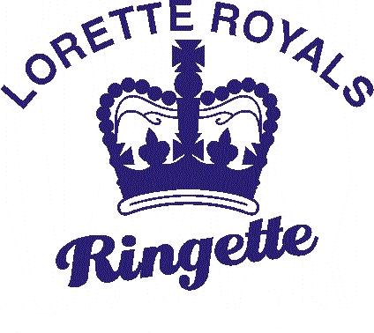

SUNDAY | MONDAY | TUESDAY | WEDNESDAY | THURSDAY | FRIDAY | SATURDAY
1

11:30 Century
Fort Garry (Charles) vs. Royals
2 | 3  7:00 East End 2  Park City Wildcats vs. Royals | HS Hockey 4  9:00 Lorette | 5 | 6 | 7 | 8
9  7:15 Keith Bodley  Kirkfield Westwood vs. Royals | 10 | 11  9:00 Lorette | 12 | 13 | 14 | 15
16 | 17 | 18  9:00 Lorette | 19 | 20 | 21 | 22
23 | 24 | 25  9:00 Lorette | 26 | 27 | 28

