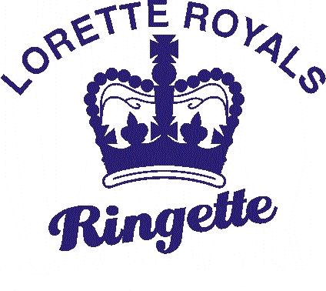 | Lorette  Ringette  Association
Pre-Season Conditioning Camp

We are pleased to announce Lorette Ringette’s first ever pre-season conditioning camp. This year we were able to heavily subsidize this fantastic skills camp due to a successful 2015 Bottle Drive.

A BIG “THANK YOU” goes out to Rothsay and Centennial Gravel for their generous battery donations and to all of the volunteers that helped make these events FUN and profitable.

What you get  - 2 Certified MB Ringette Instructors  - Certified MB Ringette Goalie Coach  - Professionally Planned Practices  - 4 Hours on Ice  - 1 Exhibition Game/Age Group  - A Chance to Improve Your Skills with Friends Before the Start of the Season | Skills To Be Practiced  - Proper Stance and Stride  - Backwards Skating  - Explosive Starts  - Stopping in All Directions  - Power Skating  - Shooting  - Goalie Skills
The camp runs for 4 weeks, September 18th - October 16th in Iles des Chenes.
We strongly encourage all players registered for the 2016-2017 season to participate.
Cost to register is $15 for LRA registered players, $60 for unregistered participants.

-----------------------------------------------------------------------------------------------------------------------------------------------------

2016-2017 Lorette Ringette Preseason Conditioning Camp

Participant:______________________________________________________________________________
Date of Birth:____________________________________________________________________________
2016-17 Age Group (circle one): U10 (Group 1) U12 (Group 1 or 2) U14 (Group 2)
Goalie? (circle one): Yes / No / Thinking About It (U10 and U12)
Parent/Guardian Signature:___________________________________________________________________

Date Arena Time Group

September 18 IDC 5:45pm 1
September 18 IDC 7:00pm 2

September 24 IDC 1:30pm U12 Game

September 25 IDC 4:30pm 1
September 25 IDC 5:45pm 2

October 2 IDC 4:15pm 1
October 2 IDC 5:30pm 2
October 2 IDC 6:45pm U19

October 6 IDC 6:15pm 1
October 6 IDC 7:30pm 2

October 16 IDC 4:15pm U10 Game
October 16 IDC 5:30pm U14 Game
October 16 IDC 6:45pm U19 Game

